**ADJECTIVES – ed/-ing**

**Directions:** Fill in the blanks with the correct form of the word shown in brackets.

1.  The documentary they showed was very __________ (interest).

2.  The pupils seem __________ (distract) in their math class.

3. When the football season ended, the fans were rather ___________ (disappoint)

their team came in second place.

4. Knowing how _________ (worry) my mother can get, I phone her every day.

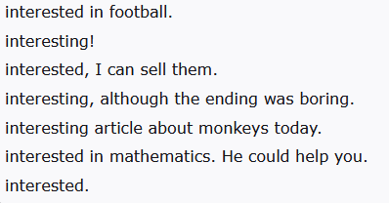5. I can hear banging noises in my office all day due to the construction work going

on.  It really ________ (disturb) me.

|  |  |
| --- | --- |
| 1. That sounds....... |  |

|  |
| --- |
|  |
| 1. Your friend seems.................. |  |

|  |
| --- |
|  |
| 1. I have some tickets for the concert. If you’re..... |  |

|  |
| --- |
|  |
| 1. I’m selling my old car. Someone might be....... |  |
| 1. I don’t understand algebra. – Well, Marc is............ | | |  |

|  |  |
| --- | --- |
|  | |
| 1. We’ve read an............. | |  |
| 1. The movie was........... |

**Answer Key:**

1. interesting
2. distracted
3. disappointed
4. worried
5. disturbs